Software Design Document
<Smart Beauty & Fashion Assistant >



Submitted by
<Ayesha Ashraf (F22BINFT1M01030)>

Submitted to
<Dr Muhammad Asadullah>

Department of Information Technology
Faculty of Computing
The Islamia University of Bahawalpur

Summery
This Software Design Document (SDD) describes the design and architecture of the Smart Beauty & Fashion Assistant, a web-based application developed to provide personalized beauty and fashion recommendations. The system assists users in selecting suitable skincare routines, makeup styles, outfits, hairstyles, and accessories based on user input such as skin type, occasion, preferences, and trends.The purpose of this document is to present the design considerations, system architecture, data models, and user interface details. The application is designed as a simple, interactive, and user-friendly web system using HTML, CSS, and JavaScript, focusing on usability, modularity, and scalability.

Table of Content
- Application Architecture
  - Architecture Overview
  - MVC Components
  - UML Diagrams
  - Coding Conventions
- Data Model Schema
  - Entity Details
  - ER Diagram
- User Interface
  - Design Philosophy
  - Screen List & Controls

- Application Architecture
The Smart Beauty & Fashion Assistant follows the MVC (Model-View-Controller) architectural pattern to ensure modularity, separation of concerns, and scalability.

1.1 Architecture Overview
The system is divided into three main layers:
- Model: Manages data, business logic, and database interactions.
- View: Handles the presentation layer (UI).
- Controller: Acts as an intermediary between Model and View, processing user requests and returning responses.

Proposed Technology Stack:
- Frontend: HTML5, CSS3 (Tailwind CSS), JavaScript ES6+
- Backend: PHP (with Laravel-like structure) or Node.js (Express.js)
- Database: MySQL
- Hosting: GitHub Pages / Simple PHP Hosting
- Version Control: Git & GitHub

1.2 MVC Components

Models (Data Entities):
- User – Stores user profile data (name, email, skin type, body type, etc.).
- Recommendation – Stores generated recommendations for skincare, makeup, outfit, etc.
- SavedLook – Stores user’s saved favorite looks.
- Questionnaire – Stores user inputs from the styling questionnaire.

Views (UI Pages):
- register.php / register.html – User registration page.
- login.php / login.html – User login page.
- dashboard.php / dashboard.html – User dashboard after login.
- questionnaire.php / questionnaire.html – Input collection form.
- results.php / results.html – Displays personalized recommendations.
- saved-looks.php / saved-looks.html – View saved recommendations.

Controllers (Logic Handlers):
- AuthController – Handles user registration and login.
- QuestionnaireController – Processes user inputs from the questionnaire.
- RecommendationController – Generates recommendations based on rules.
- SaveController – Manages saving/retrieving favorite looks.
- ColorAnalysisController – Handles skin tone detection and color suggestions.

APIs (If applicable):
- /api/login – POST request for user authentication.
- /api/recommend – POST request to generate recommendations.
- /api/save-look – POST request to save a look.

1.3 UML Diagrams
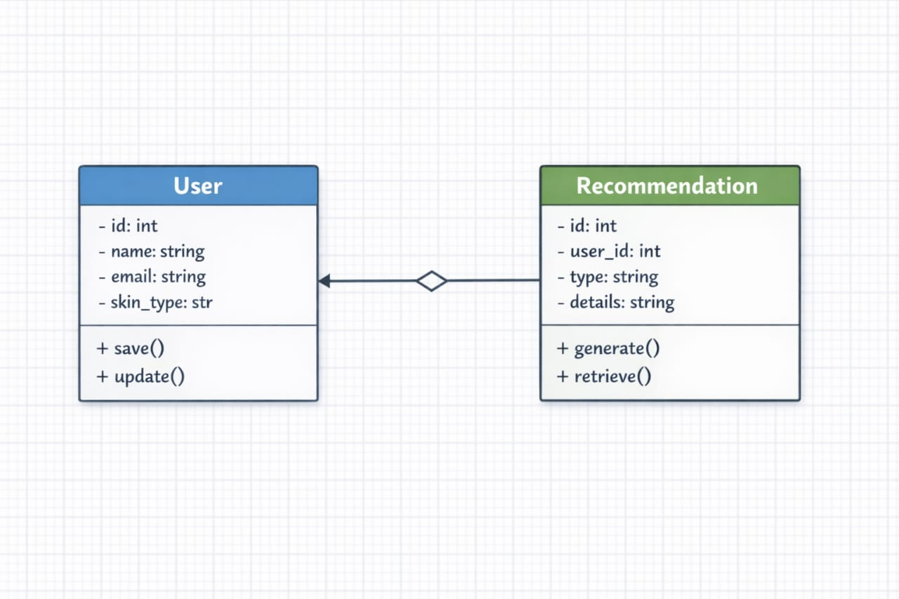

Sequence Diagram – Recommendation Flow:
1. User submits questionnaire.
2. Controller validates inputs.
3. Recommendation engine processes rules.
4. Results are displayed in the View.
5. User may save results (SavedLook).
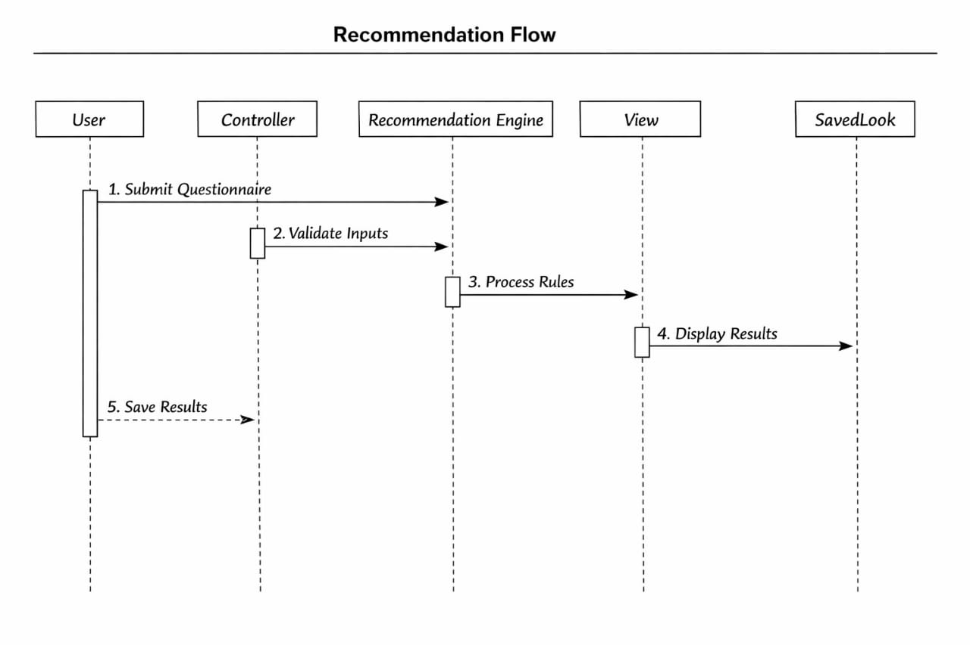

1.4 Coding Conventions
- Naming: camelCase for variables/functions, PascalCase for classes.
- Indentation: 4 spaces (no tabs).
- Comments: Use PHPDoc / JSDoc for functions.
- File Structure: Organized by feature (e.g., auth/, recommendations/).

- Data Model Schema
The database is relational, designed to store user profiles, questionnaire inputs, and recommendations.

2.1 Entity Details
- User Table (users):
- id (PK, INT, Auto Increment)
- name (VARCHAR 100)
- email (VARCHAR 100, Unique)
- password (Hashed, VARCHAR 255)
- skin_type (ENUM: ‘Oily’, ‘Dry’, ‘Combination’, ‘Normal’)
- body_type (ENUM: ‘Hourglass’, ‘Pear’, ‘Rectangle’, etc.)
- face_shape (ENUM: ‘Oval’, ‘Round’, ‘Square’, etc.)
- created_at (TIMESTAMP)

- Questionnaire Table (questionnaires):
- id (PK, INT)
- user_id (FK → users.id)
- occasion (VARCHAR 50)
- weather (VARCHAR 50)
- preferences (TEXT)
- photo_url (VARCHAR 255, Optional)

- Recommendations Table (recommendations):
- id (PK, INT)
- user_id (FK → users.id)
- category (ENUM: ‘Skincare’, ‘Makeup’, ‘Outfit’, ‘Hairstyle’, ‘Jewelry’, ‘Colors’)
- suggestion (TEXT)
- generated_at (TIMESTAMP)

- SavedLooks Table (saved_looks):
- id (PK, INT)
- user_id (FK → users.id)
- recommendation_ids (JSON or separate relation)
- saved_at (TIMESTAMP)

2.2 ER Diagram

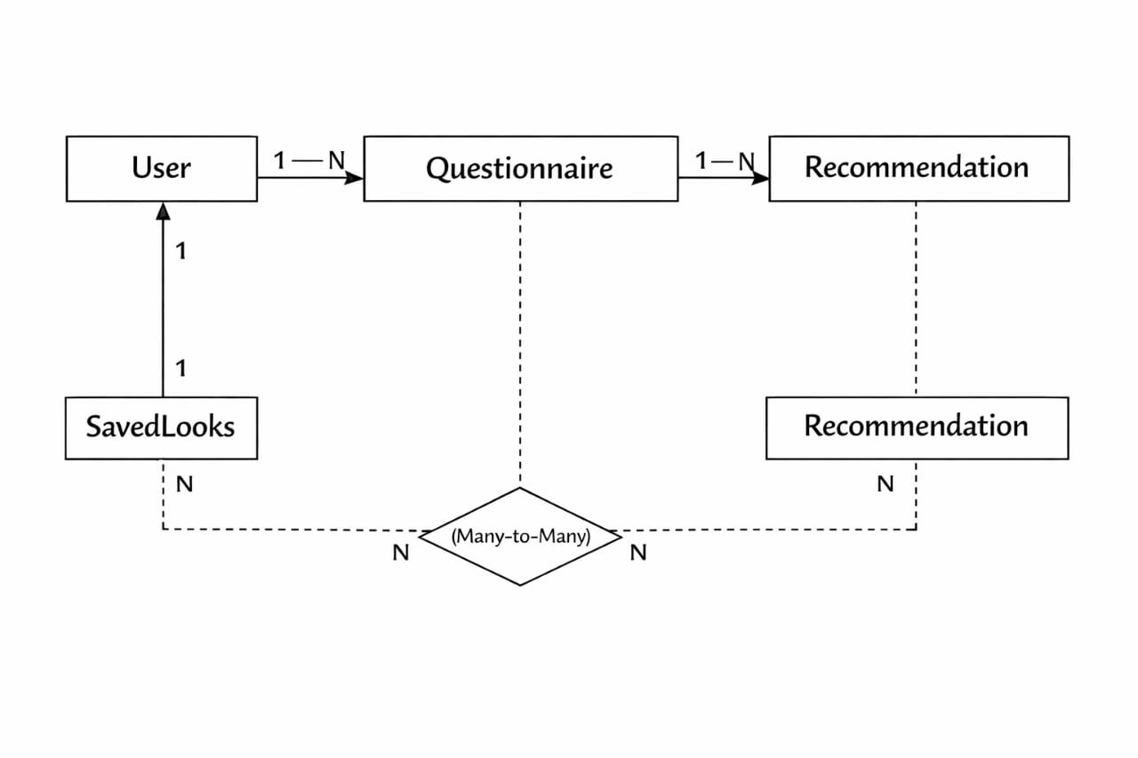

- User Interface
3.1 Design Philosophy
- Color Scheme: Soft pastels (pink, peach, lavender) for a beauty/fashion aesthetic.
- Font: Google Fonts – ‘Poppins’ for headings, ‘Open Sans’ for body.
- Design Niche: Minimalist, feminine, user-friendly.
- Responsiveness: Mobile-first approach, compatible with all screen sizes.

3.2 Screen List & Controls

1. Registration Page
- Controls:
- Textboxes: Name, Email, Password, Confirm Password
- Dropdowns: Gender, Skin Type, Body Type, Face Shape
- Button: “Sign Up”
- Input Constraints:
- Email must be valid.
- Password ≥ 8 chars, must include a number.

2. Login Page
- Controls:
- Textboxes: Email, Password
- Button: “Login”
- Link: “Forgot Password?”

3. Dashboard
- Controls:
- Menu: “Take Questionnaire”, “View Saved Looks”, “Logout”
- Welcome message with user’s name.

4. Questionnaire Page
- Controls:
- Radio Buttons: Skin Type, Body Type, Face Shape
- Dropdowns: Occasion, Weather
- Textarea: Preferences
- File Upload: Photo (optional)
- Button: “Submit”

5. Results Page
- Controls:
- Sections: Skincare, Makeup, Outfit, Hairstyle, Jewelry, Colors
- Buttons: “Save This Look”, “Retake Questionnaire”

6. Saved Looks Page
- Controls:
- List of saved looks (cards).
- Button: “Delete” per card.

